FITZONE DOCUMENTATION

By: Elena Marie de Leon

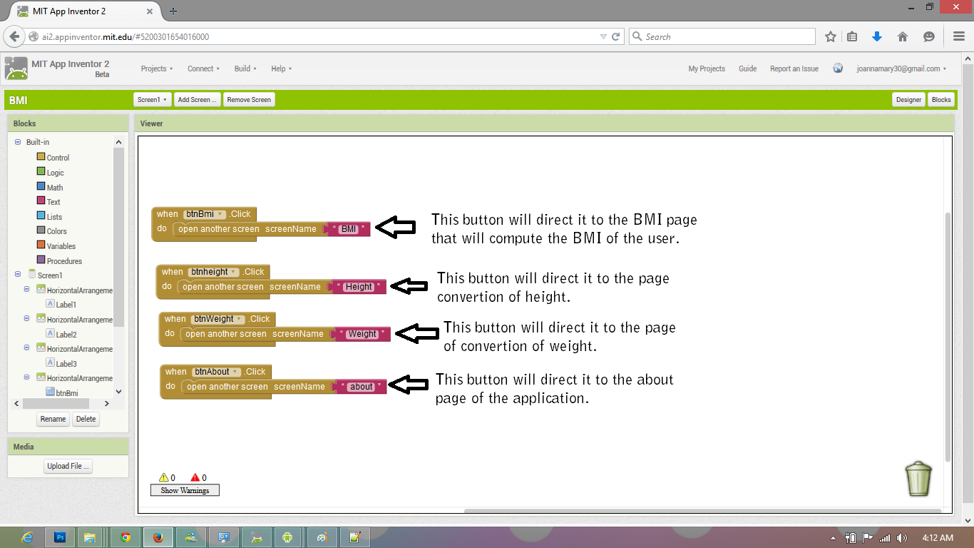HOME PAGE

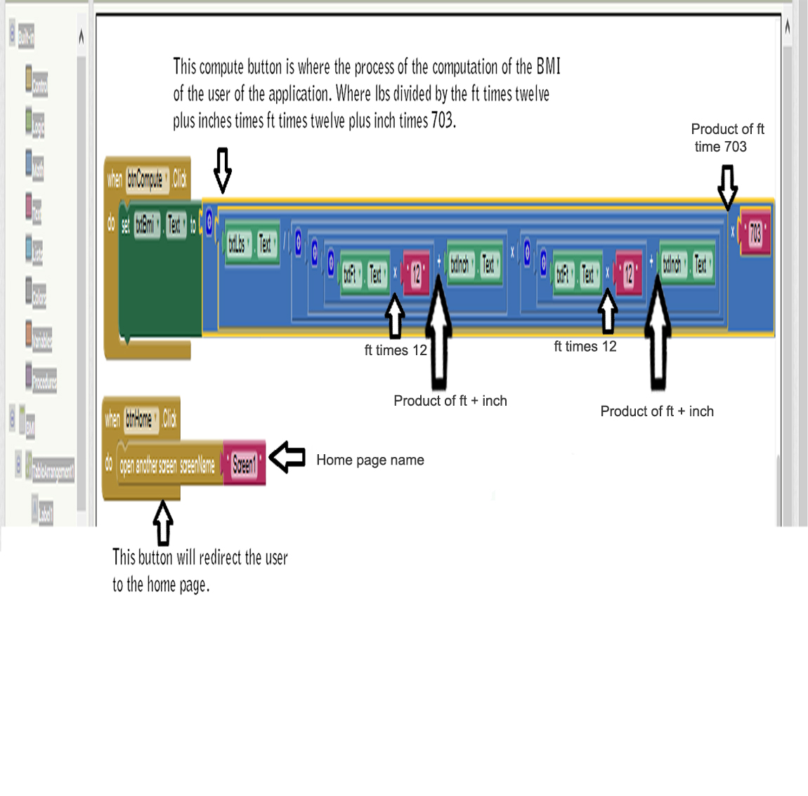BMI PAGE

HEIGHT CONVETER PAGE



WEIGHT CONVERTER PAGE

ABOUT PAGE

